Assignment -1

Python Programming

|  |  |
| --- | --- |
| Assignment Date | 9 october 2022 |
| Student Name | AARTHI V |
| Student Roll Number | 111519104001 |
| Maximum Marks | 2 Marks |

# Question-1:

Download the Dataset

Solution:

from google.colab

import drivedrive.mount('/content/drive')

# # # #

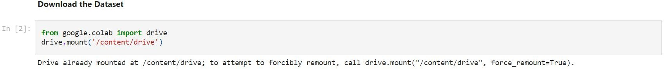

Question-2:

Image Augmentation

Solution :

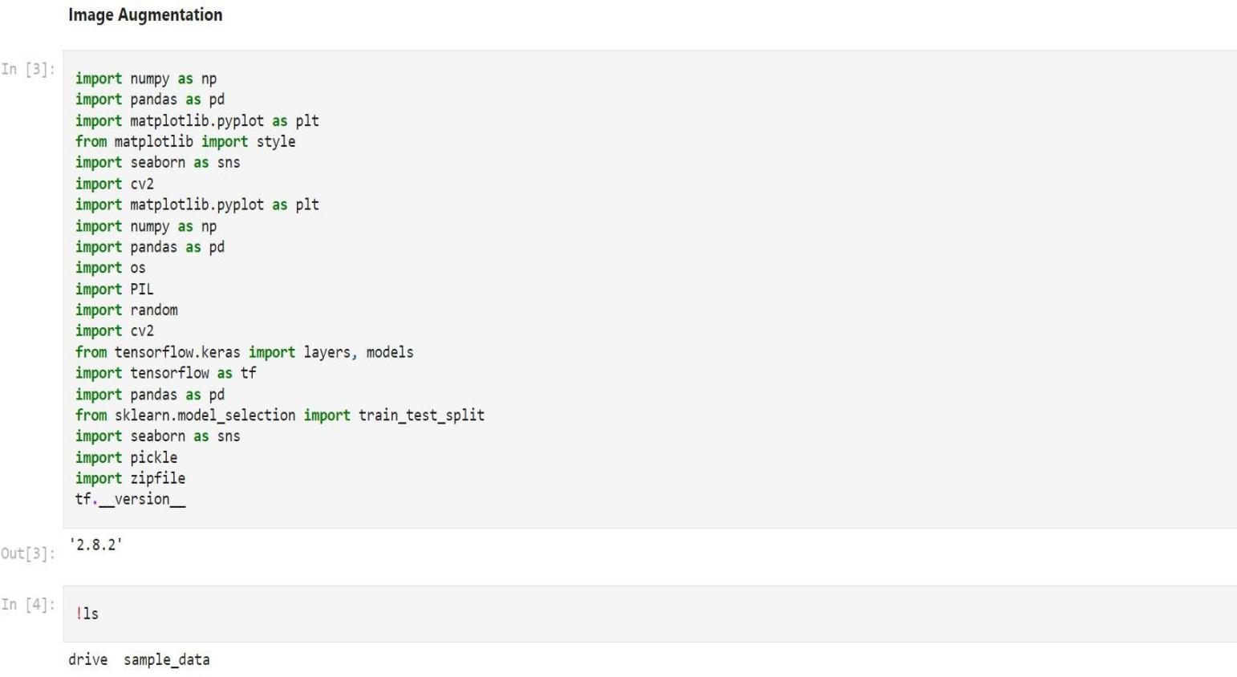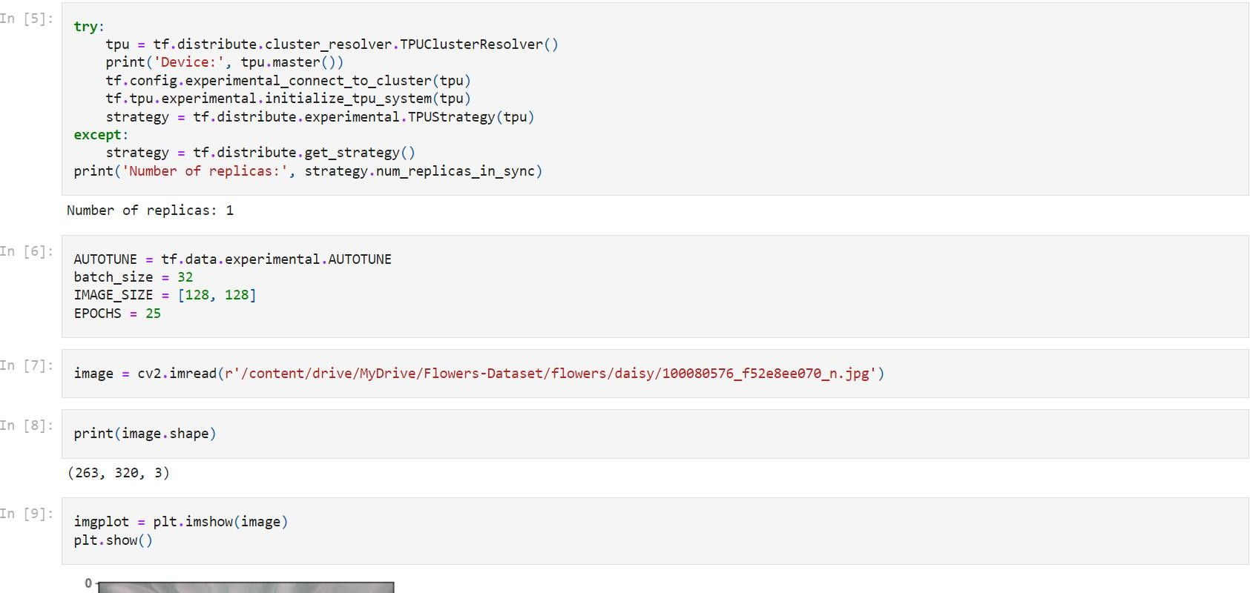

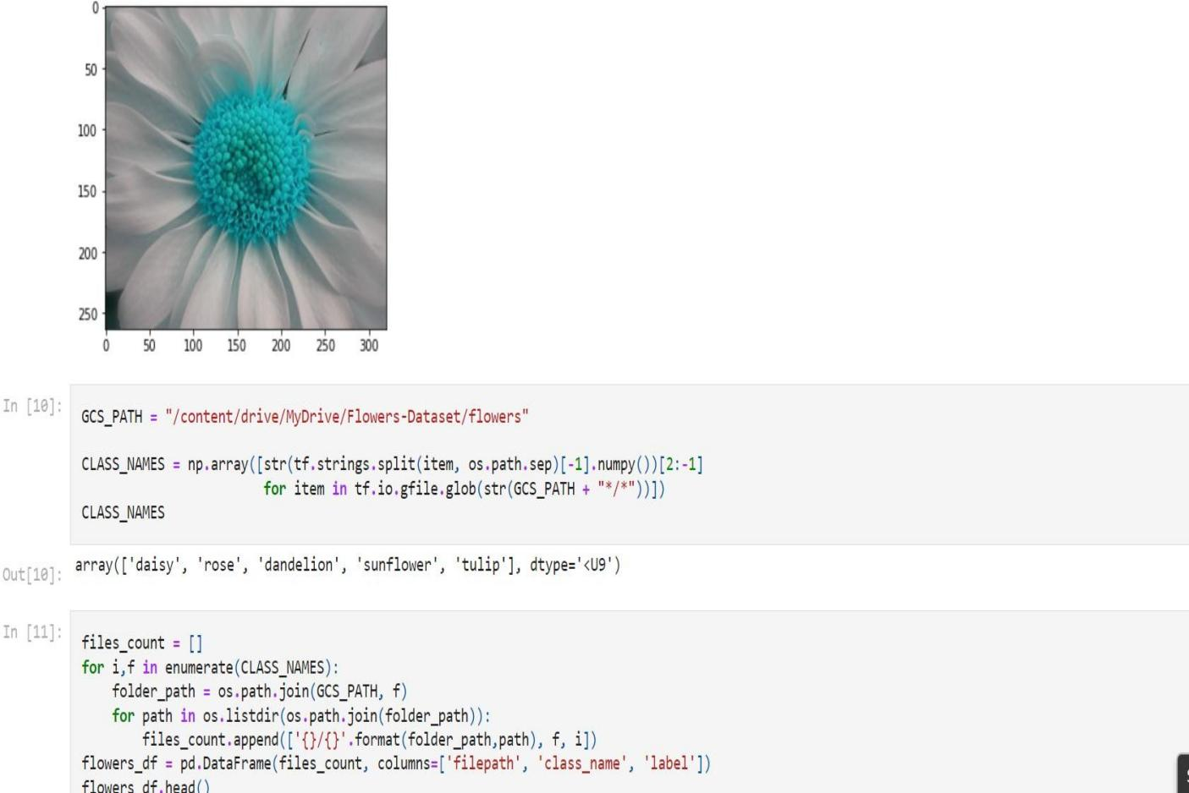

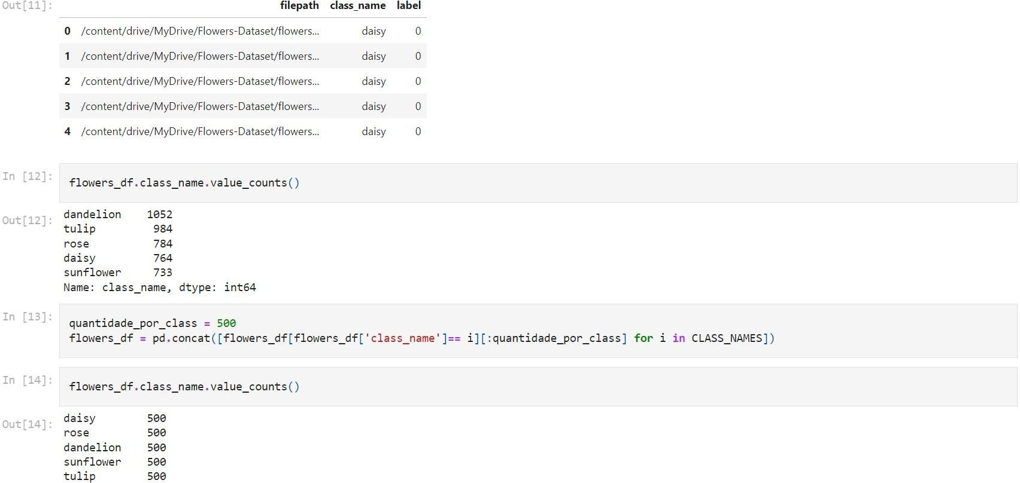

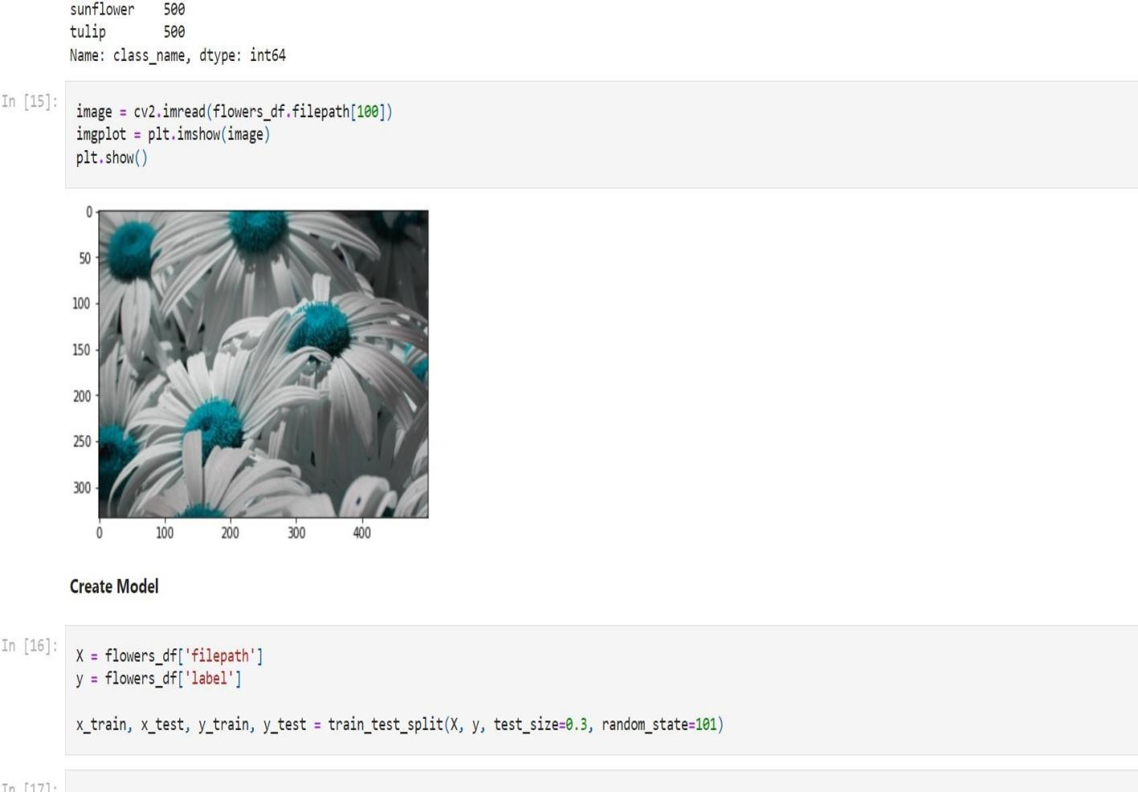

**Question-3: Create Model** Solution :

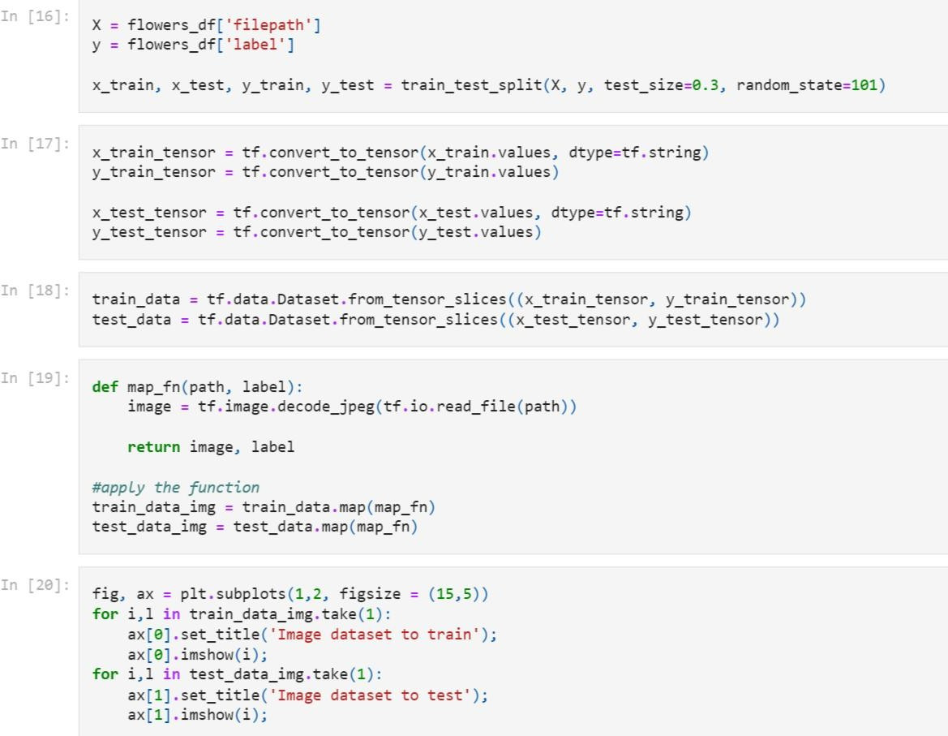

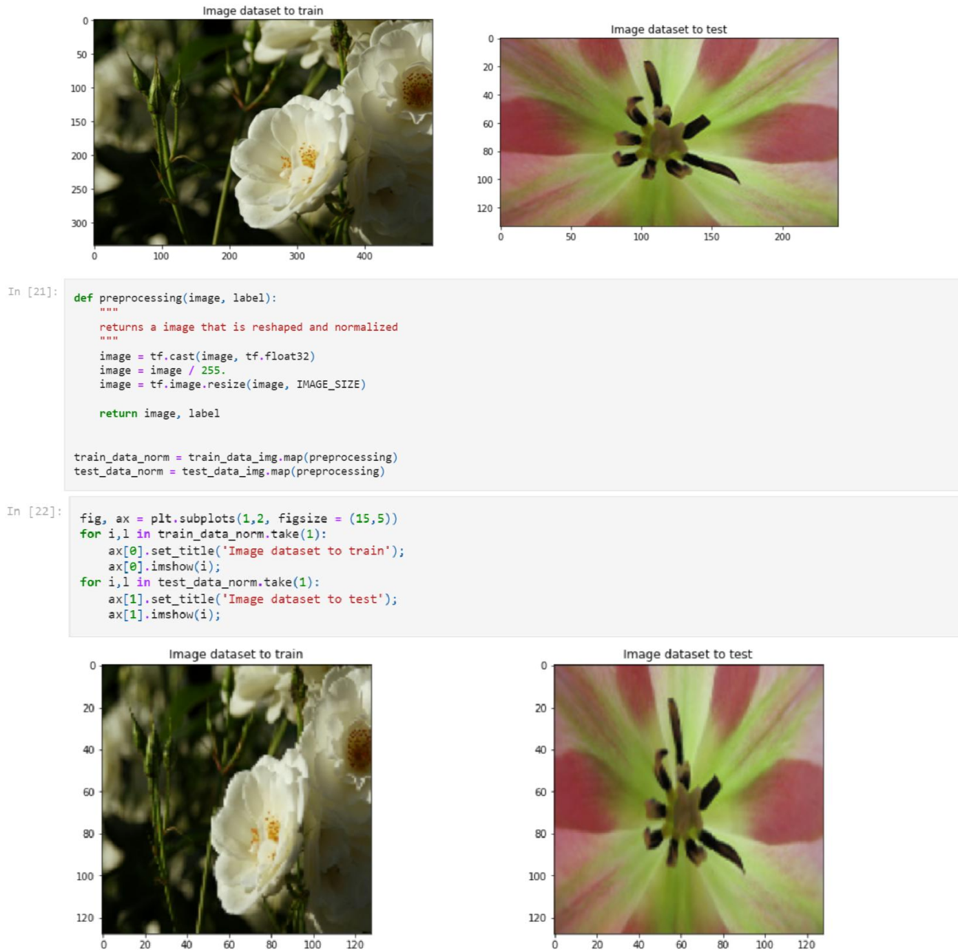

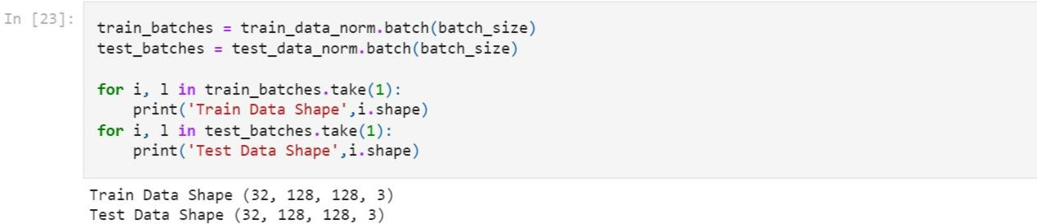

# Question-4 :

Add Layers (Convolution,MaxPooling,Flatten,Dense-(Hidden Layers),Output)

Solution :

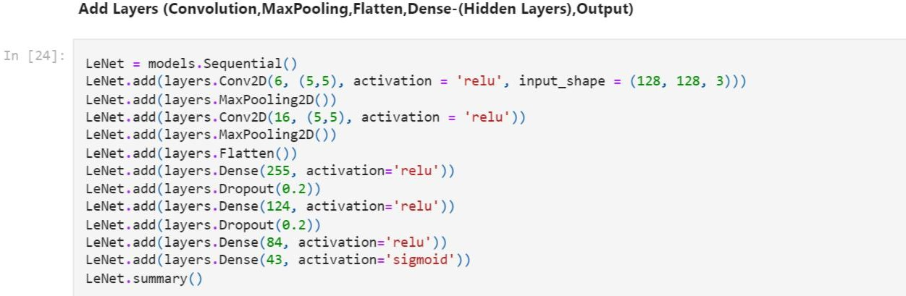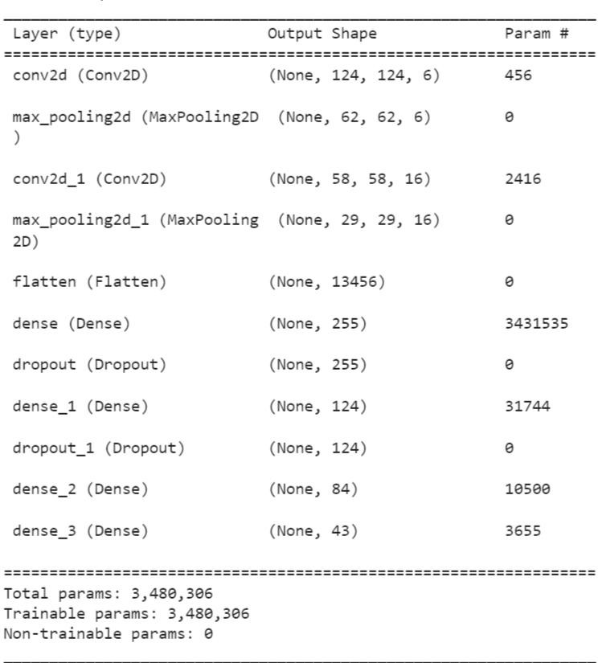

**Question-5: Compile The Model** Solution :

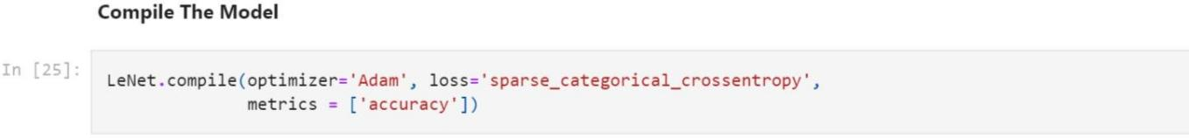

# Question-6:

Fit The Model

Solution :

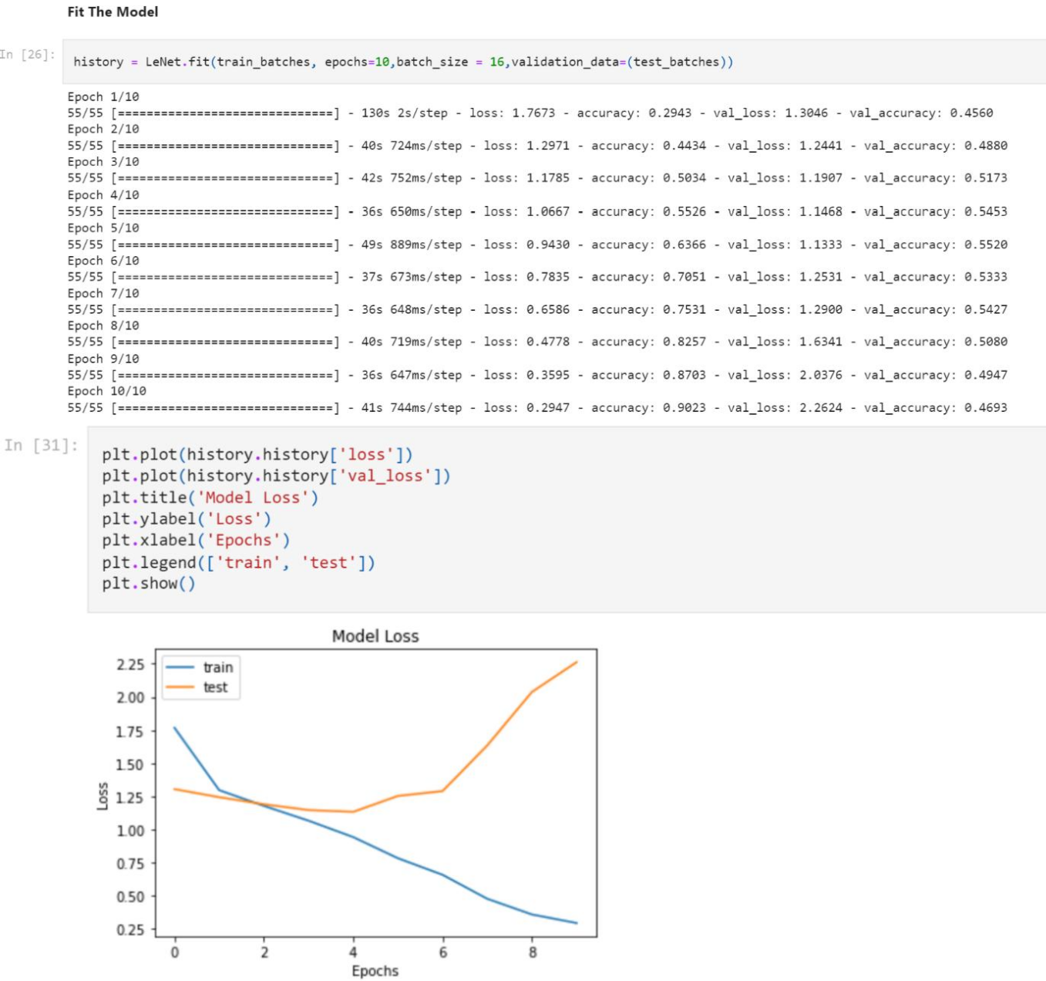

# Question-7:

**Save the Model**

Solution :

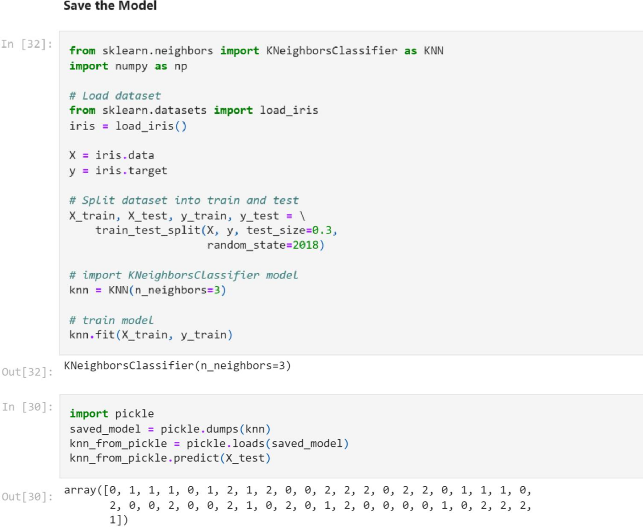

# Question-8:

Test The Model

Solution :

